ASSIGNMENT 6.3:

Problem 1:

Find the number of Google Knowledge Occupation people who were guests in the show, in a particular time period. Take the time period as 1/11/99 to 6/11/99 i.e., 6 months

Driver Class:

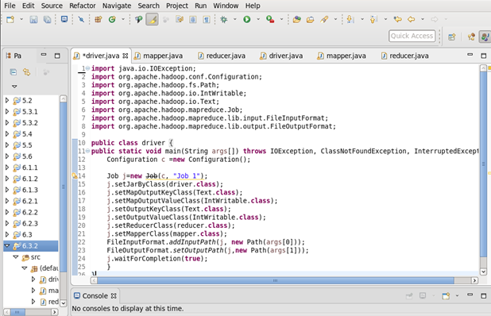

Mapper Class :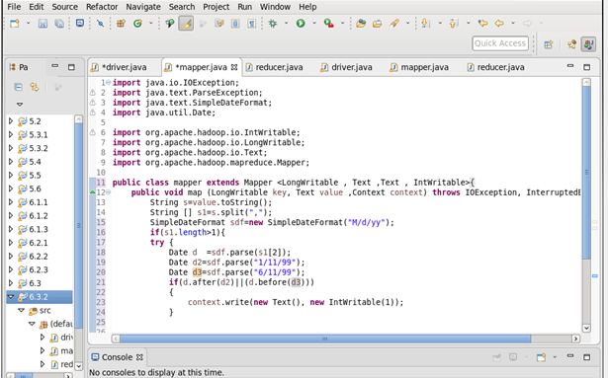

Reducer Class:

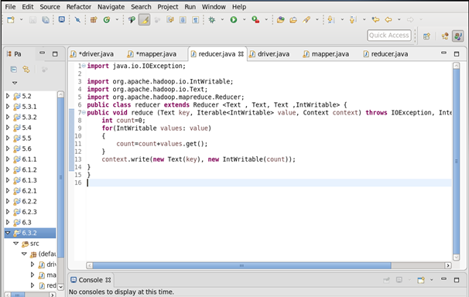

Output:

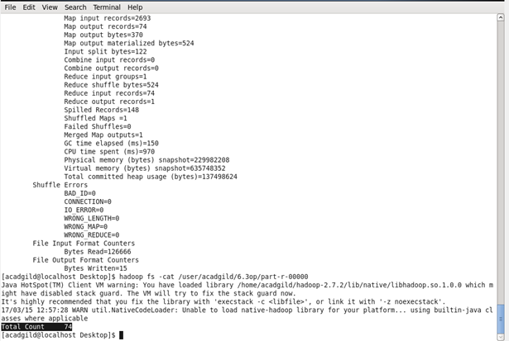

Problem 2:

Find the number of GoogleKnowledge occupation types in each group, who have been guests on the show.

Driver Class:

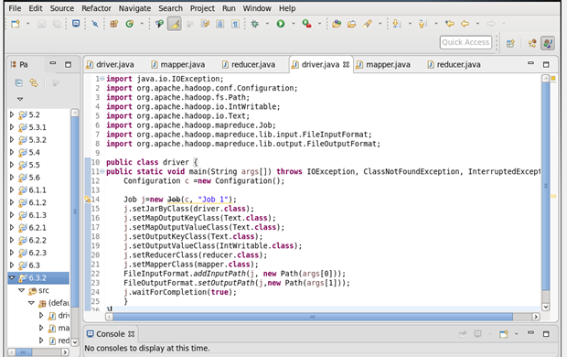

Mapper Class :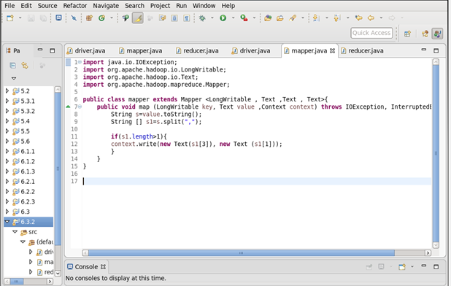

Reducer Class:

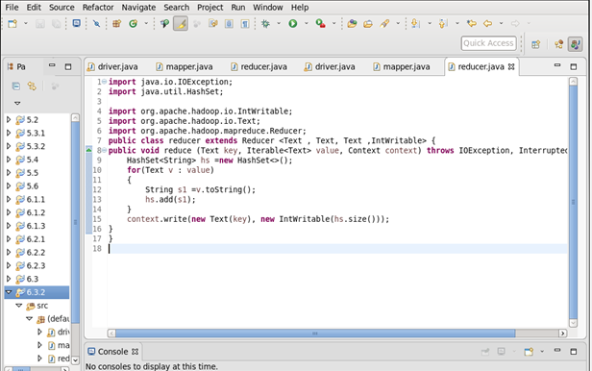

Output:

